The Amberley Society
The aim of the Society is the conservation and improvement of the amenities, character and interests
of Amberley and its surroundings
www.amberleysociety.co.uk

Newsletter February 2022

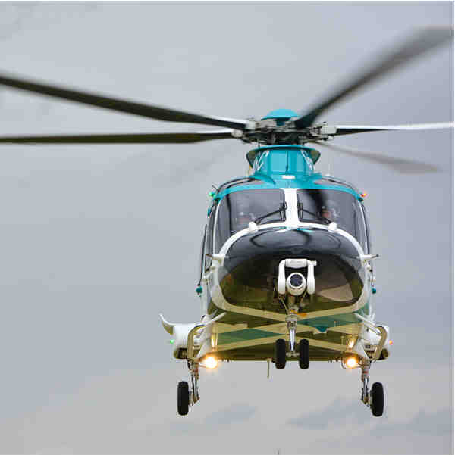

Annual General Meeting

AIR AMBULANCE
Kent Surrey Sussex

Speaker Simon Norris Jones

Friday March 11, 7:30pm

St. Michael’s Church Hall, Amberley

Next Meeting – Air Ambulance Kent Surrey Sussex

Doors will open just before 7pm and we ask members to arrive in good time. We are monitoring the Covid situation but would prefer attendees to wear a face covering and please do not attend if you have any symptoms.

Before the talk on the Air Ambulance there will be a few brief AGM formalities and possibly some short presentations about current projects. AGM documents will be circulated shortly.

The Air Ambulance has, unfortunately, attended Amberley several times in recent years to provide a vital service, helping to save lives in our community. Come and hear about their work, history, current fleet, operational teams, research and how you could become involved. As a charity the service is almost entirely dependent on donations and there will be an opportunity for you to support their cause and work.

Friday, March 11, 2022, at 7.30pm in St. Michael’s Church Hall. All are welcome with a nominal charge for non-members.

Our new Website is live. www.amberleysociety.co.uk

Jeff Feakins and Catherine Cunningham have done a fantastic job to get the new Amberley Society website up and running. Please note the change of title tag from .org.uk to .co.uk. There will be ongoing improvements and additional information as the website is further developed. Do have a browse and let us know if you would like to see any changes, additional material etc. Ian Galbraith, of the Amberley Social History group, is looking at ways to link in their vast amount of digital material for access via the website.

Full Fibre Broadband

Ultra-fast broadband is now available after fibre optic cables have been installed from the exchange to most local properties in the area. To complete the fibre connection to your home (FTTP: Fibre-to-the-Premises) contact your service provider.

Broadband Telegraph Poles on Houghton Hill

The view as you drive from the top of Bury Hill down the B2139 towards Houghton and Amberley has been rightly described as one of the best in Sussex. It was, therefore, alarming to discover that BT Openreach, in accordance with the Electronic Communications Code Regulations, gave 28 days’ notice to the South Downs National Park Authority of its intention to install 35 telegraph poles to carry fibre cables on the south side of the road, between Whiteways roundabout and Houghton, thus ruining the uninterrupted view.

The SDNPA alerted the Houghton parish meeting which, under its chairman and Amberley Society member Dr Charles Shaw, immediately launched a campaign to oppose the plan. The Amberley Society contacted fellow member organisations of the South Downs Network to garner additional support and guidance.

Planning restrictions have been lifted to help reduce the cost of broadband deployment in rural areas. Costs and expediency carry significant weight to help the Government reach its target of Fibre-to-the-Premises of 25 million homes by 2026. BT Openreach estimates that up to 1,000 poles will be installed across Britain’s National Parks and Areas of Outstanding Natural Beauty.

Fortunately, the Duke of Norfolk’s estate intervened and offered to discuss and explore with Openreach the possibility of an underground cable route on its land. With this offer in place Openreach subsequently withdrew its formal notice of the planned pole installations. We wait in hope that the discussions and feasibility study produce the right outcome to protect this precious Arun valley landscape.

Amberley Castle North Wall Collapse

Amberley Castle is a Grade 1 Listed building and ancient monument. On at least two occasions since 2008 the Amberley Society has expressed concern with the Castle owners about the lack of management of vegetation growth, particularly on the rear wall. Late last summer a large section of the upper level of the wall collapsed. It is close to the garderobe (the ancient privies) which are a significant architectural feature. With no sign of restoration, we alerted Amberley Parish Council, which contacted the Castle management and also sought advice from the SDNPA and Historic England. The Castle responded that it had taken appropriate advice, was satisfied that it was a localised and isolated incident and intended to monitor the situation. Neither we, the Amberley Society, nor Amberley Parish Council, are satisfied that this response is satisfactory. Historic England has said it will be taking steps to contact the owners and request a site visit.

Development works within the village.

We are receiving an unprecedented level of concern and complaints about some recent development works to houses within Amberley. Much of the problem seems to be a lack of awareness by owners but some of this has occurred as a result of relaxation of the planning system which we can do little about. There have also been examples of unauthorised work carried out in the Conservation Area and to Listed buildings. Details are important and if they are changed or lost, one by one, gradually over a period of time the overall special character and quality of our surroundings, which we value so highly, is adulterated.

Another concern frequently mentioned is the increase in light pollution, particularly from new large glazed areas, skylights and unnecessary exterior lighting which is contrary to the South Downs International Dark Night Sky Reserve, designated in 2016, or the Amberley Neighbourhood plan. Not only is there great value living in an area where we are fortunate to still be able to see stars but we should also consider the impact on wildlife. Some bright white and blue forms of LED light have been shown to be particularly bad, so therefore not necessarily as environmentally friendly as often perceived.

Please carry out your own research into these issues but here are a few links you might find interesting and useful.
PADS - Parish of Amberley Design Statement Amberley Neighbourhood Plan Conservation Area map Scarp Guidelines Conservation Area - Walls, Gates, Fences, Trees Works on Listed Buildings
South Downs Local Plan SDNPA Dark Skies Advice

Grahame Joseph
Chair
01798 831340
grahamejoseph@gmail.com

